# Screenshots

## Program 1.

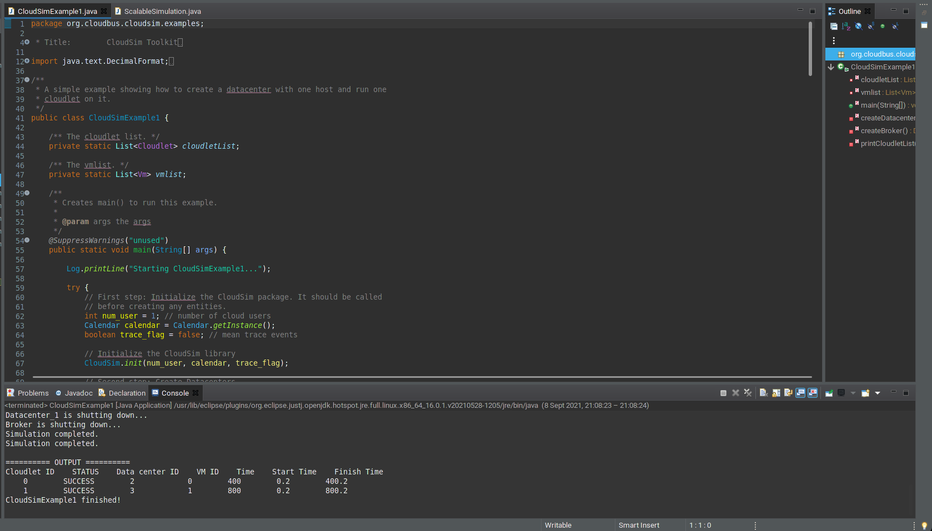

## Program 2.

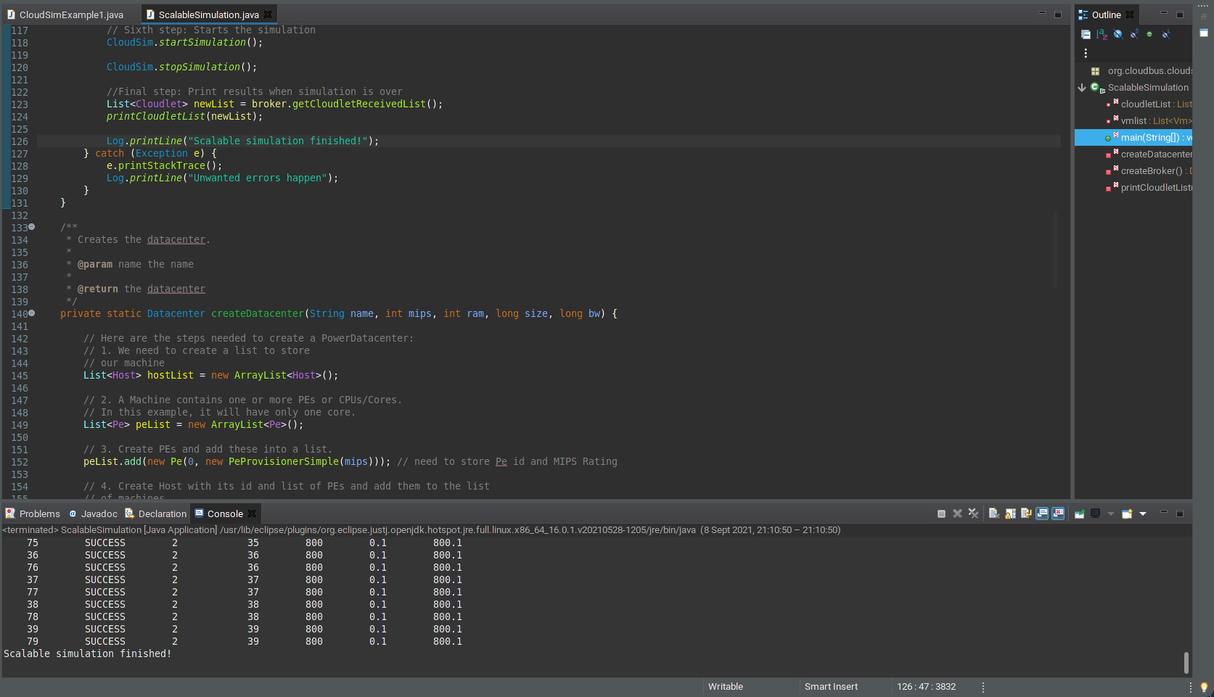

# Outputs and analysis

## Program 1.

### Output:

Starting CloudSimExample1...

Initialising...

Starting CloudSim version 3.0

Datacenter_0 is starting...

Datacenter_1 is starting...

Broker is starting...

Entities started.

0.0: Broker: Cloud Resource List received with 2 resource(s)

0.0: Broker: Trying to Create VM #0 in Datacenter_0

0.0: Broker: Trying to Create VM #1 in Datacenter_0

[VmScheduler.vmCreate] Allocation of VM #1 to Host #0 failed by MIPS

0.1: Broker: VM #0 has been created in Datacenter #2, Host #0

0.1: Broker: Creation of VM #1 failed in Datacenter #2

0.1: Broker: Trying to Create VM #1 in Datacenter_1

0.2: Broker: VM #1 has been created in Datacenter #3, Host #0

0.2: Broker: Sending cloudlet 0 to VM #0

0.2: Broker: Sending cloudlet 1 to VM #1

400.2: Broker: Cloudlet 0 received

800.2: Broker: Cloudlet 1 received

800.2: Broker: All Cloudlets executed. Finishing...

800.2: Broker: Destroying VM #0

800.2: Broker: Destroying VM #1

Broker is shutting down...

Simulation: No more future events

CloudInformationService: Notify all CloudSim entities for shutting down.

Datacenter_0 is shutting down...

Datacenter_1 is shutting down...

Broker is shutting down...

Simulation completed.

Simulation completed.

========== OUTPUT ==========

Cloudlet ID STATUS Data center ID VM ID Time Start Time Finish Time

0 SUCCESS 2 0 400 0.2 400.2

1 SUCCESS 3 1 800 0.2 800.2

CloudSimExample1 finished!

### Analysis:

When the program starts at 0.0 it tries to create two VMs and the VM #0 gets created successfully while VM #1 fails because Datacenter #2 does not have a CPU with adequate MIPS to host the VM. So, at 0.1 the broker tries to create the VM again on the next available Datacenter (Datacenter #3 in this case). The VM starts at 0.2 because when it was first allocated it failed so the broker had to try to spawn the VM again. At 0.2 the broker successfully creates VM #1 in Datacenter #3 and sends the cloudlets to the VMs (cloudlet 0 to VM #0 and cloudlet 1 to VM #1 because of the order the VMs and cloudlets were added to the broker). Then at 400.2 VM #0 finished processing the cloudlet and returned the result. Then at 800.2 VM #1 finished processing the cloudlet and returned the result and the VMs get destroyed and the simulation ends.

## Program 2.

### Output:

Starting Scalable simulation with 40 vms and 80 cloudlets...

Initialising...

Starting CloudSim version 3.0

Datacenter_0 is starting...

Broker is starting...

Entities started.

0.0: Broker: Cloud Resource List received with 1 resource(s)

0.0: Broker: Trying to Create VM #0 in Datacenter_0

0.0: Broker: Trying to Create VM #1 in Datacenter_0

0.0: Broker: Trying to Create VM #2 in Datacenter_0

0.0: Broker: Trying to Create VM #3 in Datacenter_0

0.0: Broker: Trying to Create VM #4 in Datacenter_0

0.0: Broker: Trying to Create VM #5 in Datacenter_0

0.0: Broker: Trying to Create VM #6 in Datacenter_0

0.0: Broker: Trying to Create VM #7 in Datacenter_0

0.0: Broker: Trying to Create VM #8 in Datacenter_0

0.0: Broker: Trying to Create VM #9 in Datacenter_0

0.0: Broker: Trying to Create VM #10 in Datacenter_0

0.0: Broker: Trying to Create VM #11 in Datacenter_0

0.0: Broker: Trying to Create VM #12 in Datacenter_0

0.0: Broker: Trying to Create VM #13 in Datacenter_0

0.0: Broker: Trying to Create VM #14 in Datacenter_0

0.0: Broker: Trying to Create VM #15 in Datacenter_0

0.0: Broker: Trying to Create VM #16 in Datacenter_0

0.0: Broker: Trying to Create VM #17 in Datacenter_0

0.0: Broker: Trying to Create VM #18 in Datacenter_0

0.0: Broker: Trying to Create VM #19 in Datacenter_0

0.0: Broker: Trying to Create VM #20 in Datacenter_0

0.0: Broker: Trying to Create VM #21 in Datacenter_0

0.0: Broker: Trying to Create VM #22 in Datacenter_0

0.0: Broker: Trying to Create VM #23 in Datacenter_0

0.0: Broker: Trying to Create VM #24 in Datacenter_0

0.0: Broker: Trying to Create VM #25 in Datacenter_0

0.0: Broker: Trying to Create VM #26 in Datacenter_0

0.0: Broker: Trying to Create VM #27 in Datacenter_0

0.0: Broker: Trying to Create VM #28 in Datacenter_0

0.0: Broker: Trying to Create VM #29 in Datacenter_0

0.0: Broker: Trying to Create VM #30 in Datacenter_0

0.0: Broker: Trying to Create VM #31 in Datacenter_0

0.0: Broker: Trying to Create VM #32 in Datacenter_0

0.0: Broker: Trying to Create VM #33 in Datacenter_0

0.0: Broker: Trying to Create VM #34 in Datacenter_0

0.0: Broker: Trying to Create VM #35 in Datacenter_0

0.0: Broker: Trying to Create VM #36 in Datacenter_0

0.0: Broker: Trying to Create VM #37 in Datacenter_0

0.0: Broker: Trying to Create VM #38 in Datacenter_0

0.0: Broker: Trying to Create VM #39 in Datacenter_0

0.1: Broker: VM #0 has been created in Datacenter #2, Host #0

0.1: Broker: VM #1 has been created in Datacenter #2, Host #0

0.1: Broker: VM #2 has been created in Datacenter #2, Host #0

0.1: Broker: VM #3 has been created in Datacenter #2, Host #0

0.1: Broker: VM #4 has been created in Datacenter #2, Host #0

0.1: Broker: VM #5 has been created in Datacenter #2, Host #0

0.1: Broker: VM #6 has been created in Datacenter #2, Host #0

0.1: Broker: VM #7 has been created in Datacenter #2, Host #0

0.1: Broker: VM #8 has been created in Datacenter #2, Host #0

0.1: Broker: VM #9 has been created in Datacenter #2, Host #0

0.1: Broker: VM #10 has been created in Datacenter #2, Host #0

0.1: Broker: VM #11 has been created in Datacenter #2, Host #0

0.1: Broker: VM #12 has been created in Datacenter #2, Host #0

0.1: Broker: VM #13 has been created in Datacenter #2, Host #0

0.1: Broker: VM #14 has been created in Datacenter #2, Host #0

0.1: Broker: VM #15 has been created in Datacenter #2, Host #0

0.1: Broker: VM #16 has been created in Datacenter #2, Host #0

0.1: Broker: VM #17 has been created in Datacenter #2, Host #0

0.1: Broker: VM #18 has been created in Datacenter #2, Host #0

0.1: Broker: VM #19 has been created in Datacenter #2, Host #0

0.1: Broker: VM #20 has been created in Datacenter #2, Host #0

0.1: Broker: VM #21 has been created in Datacenter #2, Host #0

0.1: Broker: VM #22 has been created in Datacenter #2, Host #0

0.1: Broker: VM #23 has been created in Datacenter #2, Host #0

0.1: Broker: VM #24 has been created in Datacenter #2, Host #0

0.1: Broker: VM #25 has been created in Datacenter #2, Host #0

0.1: Broker: VM #26 has been created in Datacenter #2, Host #0

0.1: Broker: VM #27 has been created in Datacenter #2, Host #0

0.1: Broker: VM #28 has been created in Datacenter #2, Host #0

0.1: Broker: VM #29 has been created in Datacenter #2, Host #0

0.1: Broker: VM #30 has been created in Datacenter #2, Host #0

0.1: Broker: VM #31 has been created in Datacenter #2, Host #0

0.1: Broker: VM #32 has been created in Datacenter #2, Host #0

0.1: Broker: VM #33 has been created in Datacenter #2, Host #0

0.1: Broker: VM #34 has been created in Datacenter #2, Host #0

0.1: Broker: VM #35 has been created in Datacenter #2, Host #0

0.1: Broker: VM #36 has been created in Datacenter #2, Host #0

0.1: Broker: VM #37 has been created in Datacenter #2, Host #0

0.1: Broker: VM #38 has been created in Datacenter #2, Host #0

0.1: Broker: VM #39 has been created in Datacenter #2, Host #0

0.1: Broker: Sending cloudlet 0 to VM #0

0.1: Broker: Sending cloudlet 1 to VM #1

0.1: Broker: Sending cloudlet 2 to VM #2

0.1: Broker: Sending cloudlet 3 to VM #3

0.1: Broker: Sending cloudlet 4 to VM #4

0.1: Broker: Sending cloudlet 5 to VM #5

0.1: Broker: Sending cloudlet 6 to VM #6

0.1: Broker: Sending cloudlet 7 to VM #7

0.1: Broker: Sending cloudlet 8 to VM #8

0.1: Broker: Sending cloudlet 9 to VM #9

0.1: Broker: Sending cloudlet 10 to VM #10

0.1: Broker: Sending cloudlet 11 to VM #11

0.1: Broker: Sending cloudlet 12 to VM #12

0.1: Broker: Sending cloudlet 13 to VM #13

0.1: Broker: Sending cloudlet 14 to VM #14

0.1: Broker: Sending cloudlet 15 to VM #15

0.1: Broker: Sending cloudlet 16 to VM #16

0.1: Broker: Sending cloudlet 17 to VM #17

0.1: Broker: Sending cloudlet 18 to VM #18

0.1: Broker: Sending cloudlet 19 to VM #19

0.1: Broker: Sending cloudlet 20 to VM #20

0.1: Broker: Sending cloudlet 21 to VM #21

0.1: Broker: Sending cloudlet 22 to VM #22

0.1: Broker: Sending cloudlet 23 to VM #23

0.1: Broker: Sending cloudlet 24 to VM #24

0.1: Broker: Sending cloudlet 25 to VM #25

0.1: Broker: Sending cloudlet 26 to VM #26

0.1: Broker: Sending cloudlet 27 to VM #27

0.1: Broker: Sending cloudlet 28 to VM #28

0.1: Broker: Sending cloudlet 29 to VM #29

0.1: Broker: Sending cloudlet 30 to VM #30

0.1: Broker: Sending cloudlet 31 to VM #31

0.1: Broker: Sending cloudlet 32 to VM #32

0.1: Broker: Sending cloudlet 33 to VM #33

0.1: Broker: Sending cloudlet 34 to VM #34

0.1: Broker: Sending cloudlet 35 to VM #35

0.1: Broker: Sending cloudlet 36 to VM #36

0.1: Broker: Sending cloudlet 37 to VM #37

0.1: Broker: Sending cloudlet 38 to VM #38

0.1: Broker: Sending cloudlet 39 to VM #39

0.1: Broker: Sending cloudlet 40 to VM #0

0.1: Broker: Sending cloudlet 41 to VM #1

0.1: Broker: Sending cloudlet 42 to VM #2

0.1: Broker: Sending cloudlet 43 to VM #3

0.1: Broker: Sending cloudlet 44 to VM #4

0.1: Broker: Sending cloudlet 45 to VM #5

0.1: Broker: Sending cloudlet 46 to VM #6

0.1: Broker: Sending cloudlet 47 to VM #7

0.1: Broker: Sending cloudlet 48 to VM #8

0.1: Broker: Sending cloudlet 49 to VM #9

0.1: Broker: Sending cloudlet 50 to VM #10

0.1: Broker: Sending cloudlet 51 to VM #11

0.1: Broker: Sending cloudlet 52 to VM #12

0.1: Broker: Sending cloudlet 53 to VM #13

0.1: Broker: Sending cloudlet 54 to VM #14

0.1: Broker: Sending cloudlet 55 to VM #15

0.1: Broker: Sending cloudlet 56 to VM #16

0.1: Broker: Sending cloudlet 57 to VM #17

0.1: Broker: Sending cloudlet 58 to VM #18

0.1: Broker: Sending cloudlet 59 to VM #19

0.1: Broker: Sending cloudlet 60 to VM #20

0.1: Broker: Sending cloudlet 61 to VM #21

0.1: Broker: Sending cloudlet 62 to VM #22

0.1: Broker: Sending cloudlet 63 to VM #23

0.1: Broker: Sending cloudlet 64 to VM #24

0.1: Broker: Sending cloudlet 65 to VM #25

0.1: Broker: Sending cloudlet 66 to VM #26

0.1: Broker: Sending cloudlet 67 to VM #27

0.1: Broker: Sending cloudlet 68 to VM #28

0.1: Broker: Sending cloudlet 69 to VM #29

0.1: Broker: Sending cloudlet 70 to VM #30

0.1: Broker: Sending cloudlet 71 to VM #31

0.1: Broker: Sending cloudlet 72 to VM #32

0.1: Broker: Sending cloudlet 73 to VM #33

0.1: Broker: Sending cloudlet 74 to VM #34

0.1: Broker: Sending cloudlet 75 to VM #35

0.1: Broker: Sending cloudlet 76 to VM #36

0.1: Broker: Sending cloudlet 77 to VM #37

0.1: Broker: Sending cloudlet 78 to VM #38

0.1: Broker: Sending cloudlet 79 to VM #39

800.1: Broker: Cloudlet 0 received

800.1: Broker: Cloudlet 40 received

800.1: Broker: Cloudlet 1 received

800.1: Broker: Cloudlet 41 received

800.1: Broker: Cloudlet 2 received

800.1: Broker: Cloudlet 42 received

800.1: Broker: Cloudlet 3 received

800.1: Broker: Cloudlet 43 received

800.1: Broker: Cloudlet 4 received

800.1: Broker: Cloudlet 44 received

800.1: Broker: Cloudlet 5 received

800.1: Broker: Cloudlet 45 received

800.1: Broker: Cloudlet 6 received

800.1: Broker: Cloudlet 46 received

800.1: Broker: Cloudlet 7 received

800.1: Broker: Cloudlet 47 received

800.1: Broker: Cloudlet 8 received

800.1: Broker: Cloudlet 48 received

800.1: Broker: Cloudlet 9 received

800.1: Broker: Cloudlet 49 received

800.1: Broker: Cloudlet 10 received

800.1: Broker: Cloudlet 50 received

800.1: Broker: Cloudlet 11 received

800.1: Broker: Cloudlet 51 received

800.1: Broker: Cloudlet 12 received

800.1: Broker: Cloudlet 52 received

800.1: Broker: Cloudlet 13 received

800.1: Broker: Cloudlet 53 received

800.1: Broker: Cloudlet 14 received

800.1: Broker: Cloudlet 54 received

800.1: Broker: Cloudlet 15 received

800.1: Broker: Cloudlet 55 received

800.1: Broker: Cloudlet 16 received

800.1: Broker: Cloudlet 56 received

800.1: Broker: Cloudlet 17 received

800.1: Broker: Cloudlet 57 received

800.1: Broker: Cloudlet 18 received

800.1: Broker: Cloudlet 58 received

800.1: Broker: Cloudlet 19 received

800.1: Broker: Cloudlet 59 received

800.1: Broker: Cloudlet 20 received

800.1: Broker: Cloudlet 60 received

800.1: Broker: Cloudlet 21 received

800.1: Broker: Cloudlet 61 received

800.1: Broker: Cloudlet 22 received

800.1: Broker: Cloudlet 62 received

800.1: Broker: Cloudlet 23 received

800.1: Broker: Cloudlet 63 received

800.1: Broker: Cloudlet 24 received

800.1: Broker: Cloudlet 64 received

800.1: Broker: Cloudlet 25 received

800.1: Broker: Cloudlet 65 received

800.1: Broker: Cloudlet 26 received

800.1: Broker: Cloudlet 66 received

800.1: Broker: Cloudlet 27 received

800.1: Broker: Cloudlet 67 received

800.1: Broker: Cloudlet 28 received

800.1: Broker: Cloudlet 68 received

800.1: Broker: Cloudlet 29 received

800.1: Broker: Cloudlet 69 received

800.1: Broker: Cloudlet 30 received

800.1: Broker: Cloudlet 70 received

800.1: Broker: Cloudlet 31 received

800.1: Broker: Cloudlet 71 received

800.1: Broker: Cloudlet 32 received

800.1: Broker: Cloudlet 72 received

800.1: Broker: Cloudlet 33 received

800.1: Broker: Cloudlet 73 received

800.1: Broker: Cloudlet 34 received

800.1: Broker: Cloudlet 74 received

800.1: Broker: Cloudlet 35 received

800.1: Broker: Cloudlet 75 received

800.1: Broker: Cloudlet 36 received

800.1: Broker: Cloudlet 76 received

800.1: Broker: Cloudlet 37 received

800.1: Broker: Cloudlet 77 received

800.1: Broker: Cloudlet 38 received

800.1: Broker: Cloudlet 78 received

800.1: Broker: Cloudlet 39 received

800.1: Broker: Cloudlet 79 received

800.1: Broker: All Cloudlets executed. Finishing...

800.1: Broker: Destroying VM #0

800.1: Broker: Destroying VM #1

800.1: Broker: Destroying VM #2

800.1: Broker: Destroying VM #3

800.1: Broker: Destroying VM #4

800.1: Broker: Destroying VM #5

800.1: Broker: Destroying VM #6

800.1: Broker: Destroying VM #7

800.1: Broker: Destroying VM #8

800.1: Broker: Destroying VM #9

800.1: Broker: Destroying VM #10

800.1: Broker: Destroying VM #11

800.1: Broker: Destroying VM #12

800.1: Broker: Destroying VM #13

800.1: Broker: Destroying VM #14

800.1: Broker: Destroying VM #15

800.1: Broker: Destroying VM #16

800.1: Broker: Destroying VM #17

800.1: Broker: Destroying VM #18

800.1: Broker: Destroying VM #19

800.1: Broker: Destroying VM #20

800.1: Broker: Destroying VM #21

800.1: Broker: Destroying VM #22

800.1: Broker: Destroying VM #23

800.1: Broker: Destroying VM #24

800.1: Broker: Destroying VM #25

800.1: Broker: Destroying VM #26

800.1: Broker: Destroying VM #27

800.1: Broker: Destroying VM #28

800.1: Broker: Destroying VM #29

800.1: Broker: Destroying VM #30

800.1: Broker: Destroying VM #31

800.1: Broker: Destroying VM #32

800.1: Broker: Destroying VM #33

800.1: Broker: Destroying VM #34

800.1: Broker: Destroying VM #35

800.1: Broker: Destroying VM #36

800.1: Broker: Destroying VM #37

800.1: Broker: Destroying VM #38

800.1: Broker: Destroying VM #39

Broker is shutting down...

Simulation: No more future events

CloudInformationService: Notify all CloudSim entities for shutting down.

Datacenter_0 is shutting down...

Broker is shutting down...

Simulation completed.

Simulation completed.

========== OUTPUT ==========

Cloudlet ID STATUS Data center ID VM ID Time Start Time Finish Time

0 SUCCESS 2 0 800 0.1 800.1

40 SUCCESS 2 0 800 0.1 800.1

1 SUCCESS 2 1 800 0.1 800.1

41 SUCCESS 2 1 800 0.1 800.1

2 SUCCESS 2 2 800 0.1 800.1

42 SUCCESS 2 2 800 0.1 800.1

3 SUCCESS 2 3 800 0.1 800.1

43 SUCCESS 2 3 800 0.1 800.1

4 SUCCESS 2 4 800 0.1 800.1

44 SUCCESS 2 4 800 0.1 800.1

5 SUCCESS 2 5 800 0.1 800.1

45 SUCCESS 2 5 800 0.1 800.1

6 SUCCESS 2 6 800 0.1 800.1

46 SUCCESS 2 6 800 0.1 800.1

7 SUCCESS 2 7 800 0.1 800.1

47 SUCCESS 2 7 800 0.1 800.1

8 SUCCESS 2 8 800 0.1 800.1

48 SUCCESS 2 8 800 0.1 800.1

9 SUCCESS 2 9 800 0.1 800.1

49 SUCCESS 2 9 800 0.1 800.1

10 SUCCESS 2 10 800 0.1 800.1

50 SUCCESS 2 10 800 0.1 800.1

11 SUCCESS 2 11 800 0.1 800.1

51 SUCCESS 2 11 800 0.1 800.1

12 SUCCESS 2 12 800 0.1 800.1

52 SUCCESS 2 12 800 0.1 800.1

13 SUCCESS 2 13 800 0.1 800.1

53 SUCCESS 2 13 800 0.1 800.1

14 SUCCESS 2 14 800 0.1 800.1

54 SUCCESS 2 14 800 0.1 800.1

15 SUCCESS 2 15 800 0.1 800.1

55 SUCCESS 2 15 800 0.1 800.1

16 SUCCESS 2 16 800 0.1 800.1

56 SUCCESS 2 16 800 0.1 800.1

17 SUCCESS 2 17 800 0.1 800.1

57 SUCCESS 2 17 800 0.1 800.1

18 SUCCESS 2 18 800 0.1 800.1

58 SUCCESS 2 18 800 0.1 800.1

19 SUCCESS 2 19 800 0.1 800.1

59 SUCCESS 2 19 800 0.1 800.1

20 SUCCESS 2 20 800 0.1 800.1

60 SUCCESS 2 20 800 0.1 800.1

21 SUCCESS 2 21 800 0.1 800.1

61 SUCCESS 2 21 800 0.1 800.1

22 SUCCESS 2 22 800 0.1 800.1

62 SUCCESS 2 22 800 0.1 800.1

23 SUCCESS 2 23 800 0.1 800.1

63 SUCCESS 2 23 800 0.1 800.1

24 SUCCESS 2 24 800 0.1 800.1

64 SUCCESS 2 24 800 0.1 800.1

25 SUCCESS 2 25 800 0.1 800.1

65 SUCCESS 2 25 800 0.1 800.1

26 SUCCESS 2 26 800 0.1 800.1

66 SUCCESS 2 26 800 0.1 800.1

27 SUCCESS 2 27 800 0.1 800.1

67 SUCCESS 2 27 800 0.1 800.1

28 SUCCESS 2 28 800 0.1 800.1

68 SUCCESS 2 28 800 0.1 800.1

29 SUCCESS 2 29 800 0.1 800.1

69 SUCCESS 2 29 800 0.1 800.1

30 SUCCESS 2 30 800 0.1 800.1

70 SUCCESS 2 30 800 0.1 800.1

31 SUCCESS 2 31 800 0.1 800.1

71 SUCCESS 2 31 800 0.1 800.1

32 SUCCESS 2 32 800 0.1 800.1

72 SUCCESS 2 32 800 0.1 800.1

33 SUCCESS 2 33 800 0.1 800.1

73 SUCCESS 2 33 800 0.1 800.1

34 SUCCESS 2 34 800 0.1 800.1

74 SUCCESS 2 34 800 0.1 800.1

35 SUCCESS 2 35 800 0.1 800.1

75 SUCCESS 2 35 800 0.1 800.1

36 SUCCESS 2 36 800 0.1 800.1

76 SUCCESS 2 36 800 0.1 800.1

37 SUCCESS 2 37 800 0.1 800.1

77 SUCCESS 2 37 800 0.1 800.1

38 SUCCESS 2 38 800 0.1 800.1

78 SUCCESS 2 38 800 0.1 800.1

39 SUCCESS 2 39 800 0.1 800.1

79 SUCCESS 2 39 800 0.1 800.1

Scalable simulation finished!

### Analysis:

At 0.0 the broker tries to create all the 40 VMs and at 0.1 it has successfully created all the VMs. Then at 0.1 the broker sends the cloudlets to the VMs, each VM receives two cloudlets, and each cloudlet is given to a VM in order of when they were added to the broker so VMs 0-39 would get cloudlets 0-39 then it would loop over the array of VMs. Then at 800.1 each VM finishes execution of the cloudlets and is destroyed then the simulation ends.